**Project Design Phase**

**Solution Architecture**

Date 28 June 2025

Team ID LTVIP2025TMID37321

Project Name GrainPalette - A Deep Learning Odyssey In Rice Type Classification Through

Transfer Learning

Maximum Marks 4 Marks

**Solution Architecture:**

Solution architecture is a complex process – with many sub-processes – that bridges the gap between business problems and technology solutions. Its goals are to:

● Find the best tech solution to solve existing business problems.

● Describe the structure, characteristics, behavior, and other aspects of the software to project stakeholders.

● Define features, development phases, and solution requirements.

● Provide specifications according to which the solution is defined, managed, and delivered.

**Example - Solution Architecture Diagram:**

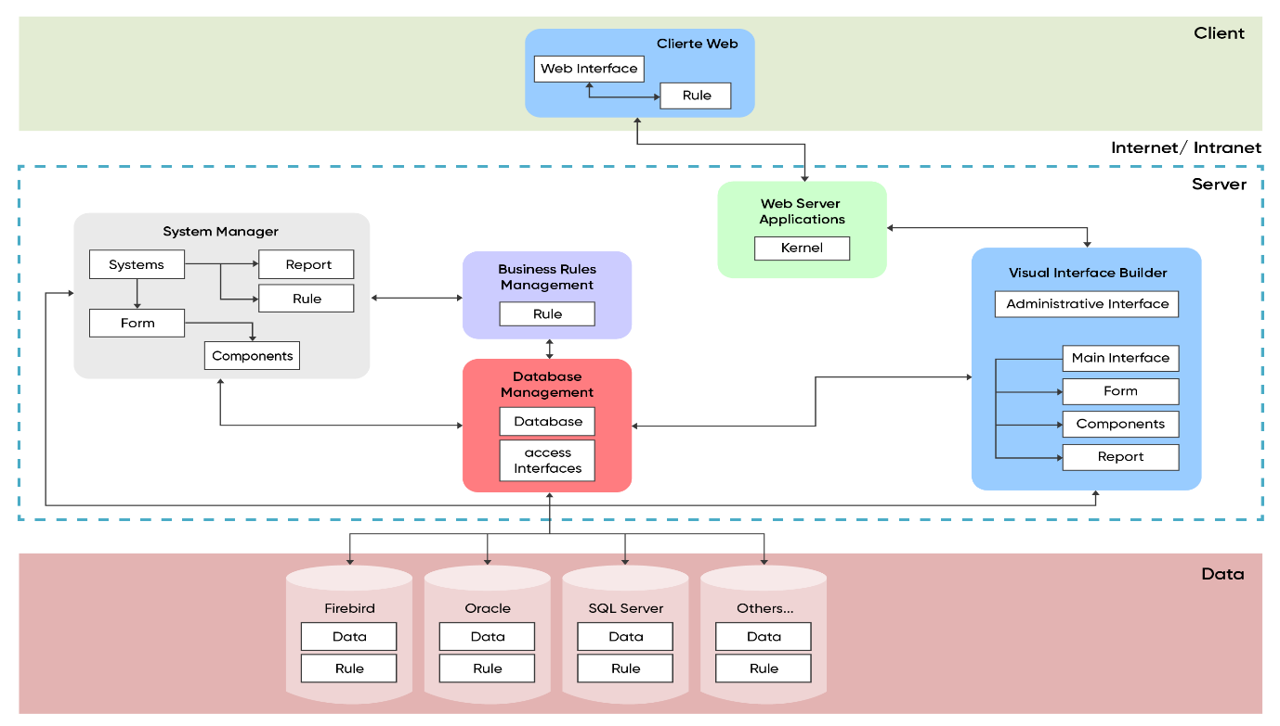

**Reference:**

https://aws.amazon.com/blogs/industries/voice-applications-in-clinical-researchpowered-by-ai-on-aws-part-1-architecture-and-design-considerations/